Westonbirt Arboretum Races – 23rd June 2024
Parking opens 06:45. Registration / Number collection from 07:10am.
Races start from 08:00am.
Westonbirt Arboretum, Westonbirt, Tetbury, GL8 8QS. W3W /// monkey.booth.motored
On the Day Registrations - Please see Schedule document for start times
1 Mile £9.50
5km £24
10km £29
Half Marathon £40
Please note the race sold out in 2023 so it is unlikely we will have spaces on the day.
Safe Race
Best summarised as; please keep a respectful distance from other runners and the event team, apply hand wash/hand sanitiser, respect other users on the route and only pass other runners or members of the public when you can do so at a comfortable distance.
In more detail;
- Please do not attend the event if you have a positive covid test. You can complete your race as a virtual, on any course and at a time of your choosing within 4 weeks of the race and we will post out your medal and goodies.
- It is expected that 5km/10km runners are self sufficient in terms of their water if possible as we are trying to minimise our environmental impact, though we have cups of water at every drinks station. We ask half marathon runners to run with their own water and refill at our drinks stations so you are well hydrated for the longer distances. There will of course be water for everyone at the finish.
- Westonbirt is fully open to the public and it always a very popular attraction. Our definition of a successful event is one that our runners enjoy and one that the wider community enjoys. More so than ever, it is vital you respect the space of other users, there are far more significant matters at play here than chasing a new PB. Please give way to other users if you can not pass safely.

Important Notices
- Parking is £5/car payable to the arboretum. Parking / Spectator Passes can be purchased alongside your race booking, or as a stand alone purchase from the Westonbirt Races homepage on the Relish Running website. Parking can only be purchased in advance, please have your confirmation email ready for checking on race day, thank you.
- There is cycle racking available in the main car park (follow those signs, rather than the Relish Running Car Park signs)
- All paths used by the race are open to general visitors, we have the site to ourselves until 9am, and from then other members of the public will be on and crossing the trails we use for our event. Please make the event a success by being polite and courteous to the other users of these paths so that the race has a positive impact on everyone involved. Please stick to the left hand side at all times and stay in single file unless overtaking
- Spectators have FREE access, only paying the parking charge, when they enter the arboretum before 9am. Spectators entering the arboretum after 9am will be asked to pay the usual visitor ticket prices.
- Please do not run with in ear, or over ear headphones as this is not permitted under UK Athletics rules. Only bone conducting headphones are permitted. This is very important so you can hear the marshals instructions, other users and traffic on the road crossing points. If you do use in ear, or over ear headphones you will be disqualified. Thank you for your understanding.
- We are no longer offering bottled water at our drinks stations or at the finish line in an effort to reduce plastic waste. There will of course be biodegradable cups on offer for you at the drinks stations as well as water containers to refill your own water bottle at each drinks station. If you are racing a long distance event, we would encourage you to bring your own water supply for after the race, after a cup or two at the finish line.

How to get to Westonbirt Arboretum
By Car – Westonbirt Arboretum, Westonbirt, Tetbury, GL8 8QS.
By Train – Kemble train station is 9 miles away and is the closest station to the arboretum.

Spectators
Spectators are very welcome to attend, Westonbirt is a wonderful family day out! Spectators have FREE access, only paying the parking charge, when they enter the arboretum before 9am. Spectators entering the arboretum after 9am will be asked to pay the usual visitor ticket prices.

Race Registration
We are not posting out any numbers for this event, all numbers will be available to collect on the day. Number Collection opens from 07:10. Registration closes 5mins before the start of the final wave. Runners who register on the day (subject to availability) will be assigned to the one wave per distance which will be open to on the day sign ups.
Please note it will not be possible to swap waves or to fit any runners into a wave once it is full or under any circumstances on the day. If you start in the incorrect wave you will be disqualified.
Bag Storage
There is a manned bag storage gazebo, with limited space. If you can leave your bag in your car or with family or friends that would be preferable and save you time. Please fill out the luggage tag provided with your race number and event or use the tear off section at the bottom of your race number.
Toilets
There are toilets as you enter Westonbirt in the main Welcome Building on your left hand side. There are also toilets in the main café, restaurant hub area, about 200m from the registration area.
Catering
There is a huge selection of cafes and restaurants at Westonbirt, perfect for spectators, brunches and lunches. A small catering unit will be open when you enter the site. The main cafes and restaurants which are situated opposite the event area open from 09:30.
Changing Tents
There are no changing tents at this race. Please come changed ready for the run. The bag drop area can look after your additional clothes and bags.
Race Start Times – PROVISIONAL Schedule
To keep the runners spread out and to ensure the event works harmoniously with everyday users we are splitting up the events into the following waves. Below are suggested arrival times.
Numbers are collected according to Event Wave
Event Wave | Race Wave | Register (approx) | Briefing | Start
1 | Half - WAVE 1 | 07:00 - 07:15 | 07:55 | 08:00
2 | Half - WAVE 2 | 07:05 - 07:20 | 08:00 | 08:05
3 | Half - WAVE 3 | 07:10 - 07:25 | 08:05 | 08:10
4 | Half - WAVE 4 | 07:15 - 07:20 | 08:10 | 08:15
5 | 1 Mile - WAVE 1 & 2 | 07:20 - 07:35 | 08:15 | 08:20
6 | 5km - WAVE 1 & 2 | 07:30 - 07:45 | 08:25 | 08:30
7 | 10km - WAVE 1 | 07:40 - 07:55 | 08:35 | 08:40
8 | 10km - WAVE 2 | 07:50 - 08:05 | 08:45 | 08:50
9 | 10km - WAVE 3 | 08:00 - 08:15 | 08:55 | 09:00
10 | 10km - WAVE 4 | 08:10 - 08:25 | 09:05 | 09:10
11 | 10km - WAVE 5 | 08:20 - 08:35 | 09:15 | 09:20
12 | 10km - WAVE 6 | 08:30 - 08:45 | 09:25 | 09:30

Notes
OTD? = Places available on the day, on a first come first served basis. TBC once advanced bookings close.

Race Briefing
There will be a briefing ahead of each wave start at the start line.
Distance Markers and GPS Route Measurements
GPS watches may struggle with the heavily tree lined area so you can expect some small differences in measurements. All our courses at Westonbirt are the correct distance.
Course Markers
All our race routes are marked with the same fairly standard Run Route arrows, our Red and White run arrows, and white and red relish running branded tape hanging from trees, as well as red flags which sit 50cm above the ground. You should be able to see one course marking or another continuously as you go around the course.
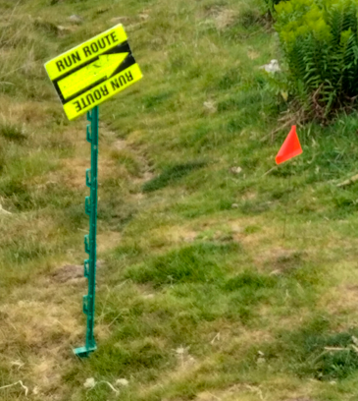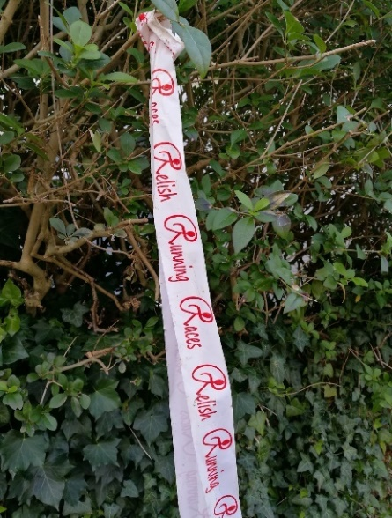
Large signs, and our marshal team, will direct the runners around the different courses based on your race number colour so please make sure that is visible and pinned to your front and keep an eye out for the giant signs!
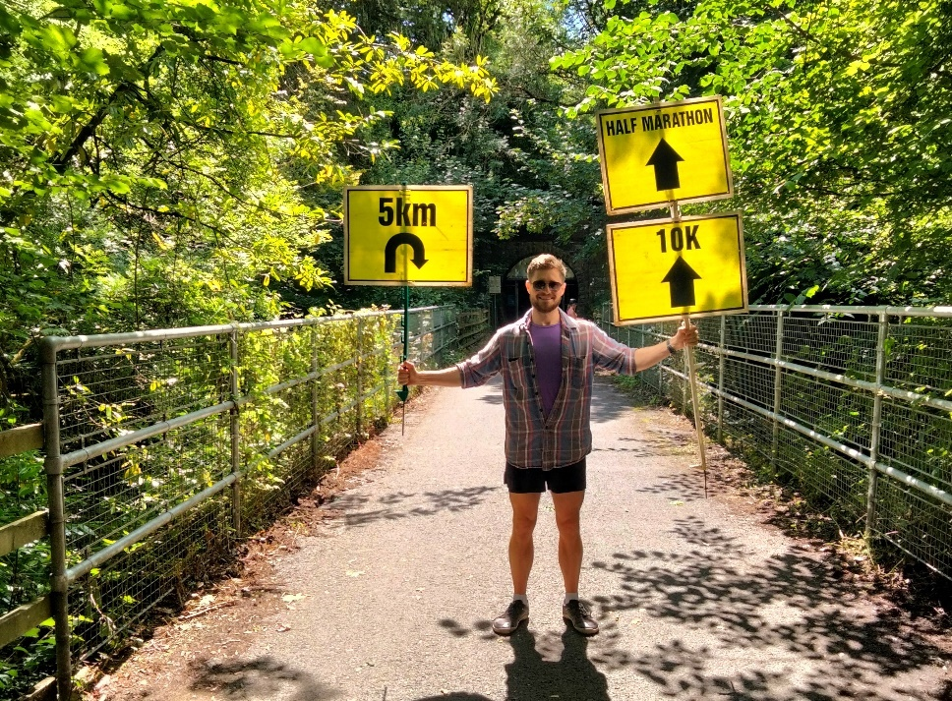

Half Marathon Distance Markers
The Half Marathon is traditionally measured in Miles, so we chose distance markers in Miles to represent the Half Marathon races.
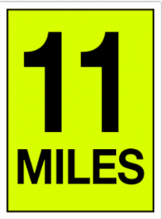
The Yellow Mile Distance Markers are for the Half Marathon. You should expect to see all distance markers. We are only putting out 1-13 miles as it is a two lap course.

10km
As this is a metric event, so are their distance markers.
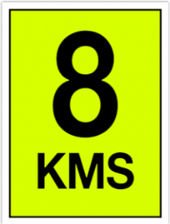

The Yellow KM Distance Markers are for the 10km. You should expect to see all distance markers

5km
As this is a metric event, so are their distance markers.
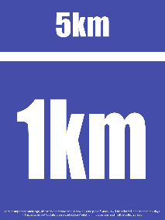
The Blue KM Distance Markers are for the 5km. You should expect to see 1km, 2km, 3km and 4km markers out on the course.

Route Descriptions
1 Mile Fun Run
> 1 loop course
This is a single lap course through the old arboretum. Parents are encouraged to accompany, free of charge. We only ask parents to register and pay if you wish to collect your own finishers medal. All children will of course collect a finisher’s medal
5km Brief Route Description
> 1 loop course
The 5km has an initial decent and rise in the first 1.2km, from here it all on the flat through the beautiful old arboretum. The 5km splits off the main 10km/Half Marathon route at the bottom of the first descent, about 500m into the run
10km Brief Route Description
> 1 loop course
The 10km is a single loop course, through the new and old sections of the arboretum. The route is largely flat, aside from a little rise and fall about 500m in to enter the new arboretum, and again at approx. 5.5km when the route moves across a little valley to head into the old arboretum.
Half Marathon Brief Route Description
> 2 loop course
The route is largely flat, aside from a little rise and fall about 500m in to enter the new arboretum, and again at approx. 5.5km when the route moves across a little valley to head into the old arboretum.
As you approach the finish area after your first lap, stay on the main stone path to start your second lap. You don’t peal off to run under the finish gantry. Upon completion of your second lap, then you cross the finish line.
Feast Stations
The Feed Stations will have water and electrolyte drink if the temperature is above 25 degrees. There will be a wide selection of snacks, tribe bars (GF, DF, vegan) on offer at the feed stations.
There are 1 drinks station on the 5km, 1 drinks station on the 10km and 3 drinks stations on the Half Marathon.
There will be more treats available for all runners at the finish line.

First Aid
There is a First Aider at each Feed Station as well as the Finish. If you do not feel able to complete the course or if you feel unwell please stop at your nearest Feed Station and we will arrange for you to be returned to the Start/Finish area.
Finish
After the race all runners will be awarded a medal and will be provided with a buffet of sweet tasty treats as provided at all our feed stations.
Medals
Our interlocking jigsaw medals link together with medals from all our other 2023 races so you can build to it and create your own giant medal.
Race Photos

Professional race photos are available to purchase from Blowfish Photography, you can search quickly using your race number or by uploading a selfie. You can register now to hear when your photos are up!

Photos are added to their site within 48hrs of the event and there is a 10% discount automatically applied on all purchases made with the first 48hrs of the photos going on sale.

Results
PROVISIONAL Results will be posted to our website at roughly 18:00 on race day. We will make any amends / updates from Tuesday. We record your finish time under the finish gantry and bib (race number) at the end of the finish funnel. If you escape the finish funnel then we can not record a finish time for you.
If you are unable to complete the distance for your event, you do not need to cross the finish line. However if you do, please let the timing team at the far end of the funnel know that you have dropped out.
Please only cross the finish line once. If you cross the finish line twice, with friends or family in later waves, it creates lots of confusion as we end up with two results for you!
Prizes
There will be prizes for the 5km, 10km and Half Marathon. There are no winners’ prizes for the fun run. The number of prizes awarded will depend on the number of finishers.
There are no on the day prize giving due to the large number of waves and the time intervals between waves. Prize winners will be contacted the week after the race by email.
Save the Date!
We look forward to returning to Westonbirt in June / July 2025!

