Eastnor Castle Mud Bath Event Information
28th April 2024, from 10:00am

Car Parking at Eastnor Castle Deer Park, Eastnor, HR8 1EN
What3Words Address (more accurate) /// indulgent.octpus.crunching
Registration / Number collection opens at 09:00am.
Please allow 20mins to walk from registration to the start line; not far, but a bit steep!

On the Day Registrations - please see Schedule document for start times
10km £40
6km £35
3km £25
On the day payments can be made in cash only due to poor internet signal. Places on the day are subject to availability and will be confirmed in the Final Schedule document on the Wednesday of race week.

Cash
Please note due to poor internet connectivity, we can only accept payments (for parking, food, on the day signs ups) with cash. There is no cash machine on site. Thank you.
Safe Race
Best summarised as; please keep a respectful distance from other runners and the event team, apply hand wash/hand sanitiser, respect other users on the route and only pass other runners or members of the public when you can do so at a comfortable distance.

In more detail;
- Please do not attend the event if you have a positive covid test. You can complete your race as a virtual, on any course and at a time of your choosing within 4 weeks of the race and we will post out your medal and goodies. Just email us your evidence.

- Please remember, you can pick your own line on the muddy and watery sections of the course. We want everyone to enjoy themselves, and take running lines you feel comfortable with is key to doing this. There is no pressure to run down the middle of a steep slope, sit and shuffle down, or once you have got sufficient mud up your shorts, to consider taking the firmer ground around the outside.
- If in doubt, miss an obstacle out. There is no shame in skipping something, there is no cheating, we want everyone to have a fun, safe and enjoyable time.
Important Notices
- Spectators are very welcome, including four legged spectators.

- Parking is £2 per car, payable at the entrance into the park (rather than when you have parked up, if you could have this ready that would be much appreciated)

- If you are parked on the opposite side of the road from the registration area, please take care when crossing the busy road and when moving about the car parking area.

- There are several road crossing points on the internal estate roads. It is unlikely you will see any traffic, but please be prepared to stop at any road crossing. Marshals do not have the power to stop traffic.

Car Parking
Please use the postcode for the Eastnor Deer Castle Deer Park, HR8 1EN. Please do not google Eastnor Castle as you will get the wrong postcode and probably end up driving up right to the castle doors….! What3Words indulgent.octpus.crunching will get you right to the parking entrance

When you see the large Relish Running signs (white background, red text) please follow these to the event car park and disregard your SAT NAVs instructions.

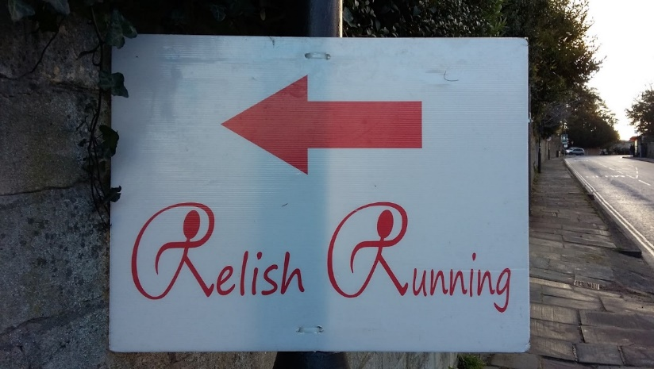

Parking is £2 per car, please follow the parking attendant's instructions to park up swiftly. Please do not chat to them about the race, we have a lot of cars to park so we need to keep things moving and ensure we don’t clog up the main road. The Event Information desk at Registration will be well placed to answer any questions.

Camping
Camping is available from 16:00 on Friday until 16:00 on Sunday. The facilities for camping include fresh water, portaloos and hot showers. There is catering a short walk from the camp site at The Woodshed. Camping is £10 / person / night and needs to be purchased in advance, either alongside your race booking or as a stand alone add on here.

Spectators
As this is a relatively narrow course that disappears into the distance we recommend that spectators stay at the Race Village site and cheer their runners in over the finish line. There is plenty of food, refreshments and the beautiful view of the castle and estate ground to enjoy in the meantime!

Race Registration
We are not posting out any numbers for this event, all numbers will be available to collect on the day. Number Collection and On the Day Registrations will open from 09:00.
Number Collection will be according to your EVENT WAVE, with signs hanging from the gazebos above the relevant desk. For example, 10km wave 1 runners may be the 5th wave to start, so their number will be collected from the desk labelled WAVE 5. Please see below for a full breakdown of waves and start times.
If you registered your runners as part of a group entry, your group’s number will be available to collect from the Event Information desk. Please nominate someone to collect the numbers from this desk and ensure everyone in your group receives their assigned number with the laminated group start list within your envelope.
Runners who register on the day will be assigned a wave according to the first available wave. Waves are not organised by predicted finish time, each wave is open to everyone to allow runners to spread out over the course.
Registration will remain open so long as there are still waves to start.
Please note it will not be possible to swap waves or to fit any runners into a wave once it is full or under any other circumstances on the day. If you start in the incorrect wave your time will not appear on the results.

Bag Storage
There is a bag storage gazebo. Please either fill out a luggage label or most race numbers have a tear off section at the bottom which can be removed and looped through your bag.

Toilets and Changing Tents
There will be portaloos by the start area. There will be a small changing tent, partitioned into male and female sections towards the finish area. We recommend you come changed ready to run, with warm clothes on top, and then get changed into them again after the event. We have a swamp near the end of the course to help wash the mud off. There are no showers, just the swamp.

Showers
The showers on site are for those runners who have camped over the weekend, they are not for general use by runners after the mud bath, thank you for your understanding.

Race Start Times
To allow the runners to spread out we are splitting up the events into the following waves. This is important for safety, to ensure runners are well spread out on the tricky sections of the course. It is also very important for our results that you do start in the correct wave so we can post accurate results.
Below are suggested times to register, the race briefing and start times. Registration/Number Collection for a particular wave remains open until it starts, these are just suggestions to allow time to drop off a bag, go to the loo, etc in good time.
This is the Provisional Schedule. It will be updated on race week. When we have the final number of runners for each wave tallied up, we can confirm the schedule on the Event Info page on the website.

Event Wave | Race Wave | Register (suggested) | Briefing | Start
1 | 3km Wave 1, 2 & 3 | 08:50 - 09:05 | 09:55 | 10:00
2 | 10km Wave 1 | 09:50 - 10:05 | 10:55 | 11:00
3 | 6km Wave 1 | 10:00 - 10:15 | 11:05 | 11:10
4 | 10km Wave 2 | 10:10 - 10:25 | 11:15 | 11:20
5 | 6km Wave 2 | 10:20 - 10:35 | 11:25 | 11:30
6 | 10km Wave 3 | 10:30 - 10:45 | 11:35 | 11:40
7 | 6km Wave 3 | 10:40 - 10:55 | 11:45 | 11:50
8 | 10km Wave 4 | 10:50 - 11:05 | 11:55 | 12:00
9 | 6km Wave 4 | 11:00 - 11:15 | 12:05 | 12:10
10 | 10km Wave 5, 6 | 11:10 - 11:25 | 12:15 | 12:20
11 | 6km Wave 5, 6 | 11:20 - 11:35 | 12:25 | 12:30

Event Timing
Our timing system relies on two things; runners starting in the correct waves (as each runner’s bib number is pre programmed with a wave adjustment time) and for us to see your bib number as you cross the line.
If you start in the incorrect wave your finish time will be incorrect and we will need to remove you from the results. And if you can keep your number clean, that would be amazing
Course Markings
Our courses are marked with the usual bright run route multi directional arrows. They are used for turns and periodically along straight ahead sections. We will also be putting down orange temporary marking paint, but given the mud on the course I would not rely on too much of this being around once the first wave of runners has gone through.
The vast majority of our courses are marked with Red flags and Relish Running Races branded tape which will be hanging from trees overhead and along the side of fences. It has a white background and a red print of the Relish Running Races logo.
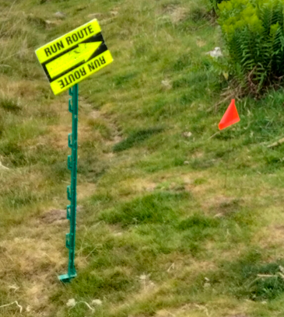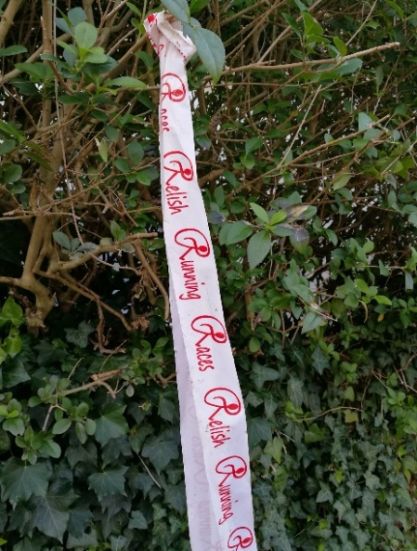
We will be using this almost entirely for the wooded section so please keep a lookout for this tape, you should be able to see one course marking pretty much continuously as you move around the course.
Refreshments
There will be a range of hot food and drinks offering for runners and spectators.
Event Finish
The event finishes at approximately 14:30
Race Photos
Professional race photos are available to purchase from Blowfish Photography, you can search quickly using your race number or by uploading a selfie. You can register now to hear when your photos are up!

Photos are added to their site within 48hrs of the event and there is a 10% discount automatically applied on all purchases made with the first 48hrs of the photos going on sale.

Results
As we are in an internet black spot and will not be leaving the race site until 10pm when everything is packed away, we will post results around midday on Monday.
Prizes
There are no winners’ prizes for the 3km events. There are prizes for the 6km and 10km, with the final quantity of prizes being dependent on the number of finishers on the day. As all the waves are mixed ability, our winner could in fact come from the final wave of the day. We will therefore not keep everybody waiting on the day and we will contact all the prize winners by the end of the week following the event once the results have been finalised.
Save The Date!
We are planning to return for our next Eastnor Mud Bath on 27th April 2025

